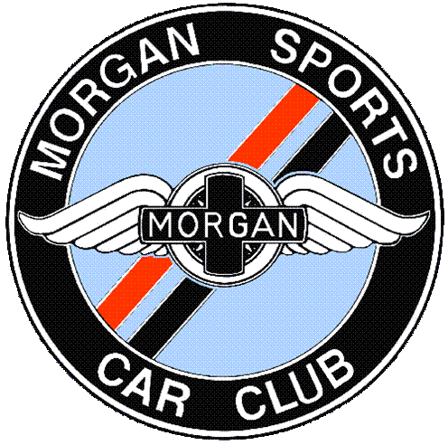

NEW MEMBERS GENERAL INFORMATION

The Morgan Sports Car Club ("MSCC") is for enthusiasts of any Morgan; it is not necessary to own a Morgan to become a member. There are approaching five thousand members world-wide with a network of thirty-five local Centres in the UK and forty-three affiliated Clubs in other countries.

The Club was formed in 1951 and was incorporated as a Limited Company in 1991.

The affairs of the Club are managed by the National Committee, the members of which are elected into office and comprise Directors, Club Officers, Centre Secretaries and other volunteer members. This structure allows for the voice of the ordinary member to be heard while providing continuity in the running of the Club.

More details are available from the Members Information document on the Club’s website -see below

Centres & Affiliated Clubs

Throughout the country, Centres meet on a regular basis for noggins, trips, shows, social events, etc. Details each month can be found in the Club magazine. Also, the Club has strong links with many overseas Clubs and an exchange of information is encouraged.

Magazine ‘Miscellany’

This is produced monthly and the paper copy is sent to all full UK members. Each new issue is loaded onto the website by the 3rd of each month accessible to all members. It includes details of Club activities; local, national and international, centre reports, technical articles, Club Officers reports, advertisements of cars for sale and other items of interest. There are also details of members’ discounts on entry to events in “What’s On”. Back issues can be read online; set a password on the login page for access. The editor welcomes and encourages articles & photographs of Morgan-related items from members.

Regalia

Club regalia are regularly sold, including the Club car badge (members only). There is also a Bookshop selling books both Morgan and Morgan-related. Details are on the website under Retail/Shop

Technical Services

The Club has a technical group that can signpost members to information on different models and older cars. An online forum has been set up for queries and comments; sign up through the members’ section of the website.

Competition

Affiliated to the Motor Sports Association (“MSUK”), the Club runs an annual sprint and production car trials. It also participates in autotests, sprints, speed hill climbs, circuit races and trials. We comply with their safeguarding policy.

Annual Mogfest Event

This is held at a different venue each year and details are given in the magazine. It is an opportunity to see a large gathering of Morgans and participate in a weekend of social and competitive events.

Partners’ Benefits
With
There are a number of partners’ benefits and we have recently set up a scheme to work Peter James Insurance in an exclusive partnership offering the service and cover expected for Morgans.
There is a growing list of discounts on merchandise; full details of all these benefits are listed in the Club magazine.
The MSCC has a Travel Club run by Scenic & Continental Car Tours and offers risk free, discounted trips to events and numerous others, with experienced operators. Local Centres also run their own tours, covered by the MSCC insurance. Our e newsletter Morganeer is e mailed in the middle of the month, which gives extra items of interest including competitions, and asking for your response. You can unsubscribe if you do not wish to receive this.

Car Register

Car details are requested on the membership application form to help compile a historical register of Morgans. This information is protected by the Data Protection Act. There is a separate Historic Register as well as one for models such as the Le Mans 62 & Roadster 100.

Website

The Club maintains a website at www.morgansportscarclub.com which is a useful source of all current and historical information about the Club together with contact details for Club Officers and other officials. When you have set a password you can log into the members’ area and access the Club handbook for extra information.
THE MORGAN SPORTS CAR CLUB LIMITED
Website www.morgansportscarclub.com

